Training And Placement System

SUBJECT: SYSTEM DESIGN PRACTICE

DHARAMSINH DESAI UNIVERSITY

COMPUTER DEPARTMENT

FACULTY OF TECHNOLOGY, NADIAD



PREPARED BY: | GUIDED BY:
Patel Vasu (CE-089)  Rajyaguru Keval (CE-098) | Dr. C.K.Bhensdadia  (Head, CE Department)
Rathod Bhargav (CE-103)

Dharmsinh Desai University
College Road, NADIAD – 387001. (GUJARAT)

CERTIFICATE

This is to certify that the term work carried out in the subject of SYSTEM
DESIGN PRACTICE and recorded in this report is the bonafide work of
Mr. Rathod Bhargav Nitinbhai (Roll No.: CE103, Identity Number: 15CEUBS037),
Mr. Rajyaguru Keval Atulkumar (Roll No.: CE098, Identity Number: 15CEUOF012),
Mr. Patel Vasu Jayeshkumar (Roll No.: CE089, Identity Number: 15CEUON018)
Of B.Tech Semester 6th in the branch of Computer Engineering during the academic year 2017-18.

Dr. C. K. Bhensdadia
(Project Guide and Head of CE Department)
Dharmsinh Desai University, NADIAD
Date :
INDEX

1. Abstract………………………………………………………………………………….04

2. Introduction…………………………………………………………………………..05

3. Software Requirement Specification………………………………………06

4. Design……………………………………………………………………………………16
4.1 Use Case diagrams
4.2 Class diagrams
4.3 Sequence diagrams
4.4 Activity diagrams
4.5 State diagrams
4.6 ER diagram
4.7 Data Dictionary

5. Implementation……………………………………………………………………31

6.Testing…………………………………………………………………………………..33

7. Screenshots…………………………………………………………………………..34

8. Conclusion…………………………………………………………………………….43

9. Limitations & Future Extension...............................................44

10. Bibliography………………………………………………………………………..45

11.Miscellaneous………………………………………………………………………46

- ABSTRACT

Goals

- The ultimate goal of 'Training and Placement System ' is to fully computerize the training and placement system of university such as student details, notice, upcoming seminar and company details etc. Student also register and place in appropriate company.

Scopes

- The Training and Placement Portal is equipped with some unique facilities like student current profile and student placement details which will be quite useful for students as well as teachers. Plus, on the administration side, facilities like Student upload via Excel file, Export Details into Excel file etc.

2. INTRODUCTION

- Now a day, In Digital world all the things are helpful when it fully speedy and efficient.

- Training and Placement System is a portal in which students are login as per his/her credentials and see current update of their profile as well as current update of University.

- As well as, any new information like a notice, circular, Announcement speedily uploaded and read by students.

- Upcoming companies, Interviews, Student ability all the aspects are covered in this portal. So, its useful for student as well as teachers too.

- This system is purely implemented in .NET framework (with c# language support) with Entity Framework. And developed in visual studio (Microsoft,2017).

3. SOFTWARE REQUIREMENT
SPECIFICATION
For
Online Training and Placement Portal
Version 1.0 approved

Introduction

Purpose
- This Software Requirements Specification provides a description of all the functions and constraints of the Placement Management System, developed for various colleges’ placement cell. The Placement Management System is for the students and companies which maintains the database for the students where all the students’ records are entered including their academic details and their personal details. It will also manage the data of the Company which would comprise of the profile of the Company, eligibility criteria and the facilities or the package it provides etc. The System would provide the facility of viewing both the personal and academic information of the student and company; it would also search for eligible students and Company and deal with the insertion and deletion of records.

Document Conventions
- We have followed IEEE standard to prepare this document. This document is formatted in natural language sentence.

Intended Audience and Reading Suggestions
- This document can be referred by software developers, documentation writers, project manager and the users.

Product Scope
- The System would store all the academic as well as personal details of the students who wish to be placed and the Companies who offer jobs to the students.
- The details of the Companies may be updated or modified or deleted to keep the information up to date. And information of students also can be updated but academic details of students only can be changed after verifying by collage.
- Also notifications would be sent to the students about the Companies i.e. details like the Company profile, eligibility criteria for the job profile etc.
- Also the information regarding the Placement activities or procedure for a particular Company i.e. the selection rounds or procedure. And Experience, reviews, suggestion and interview tips by placed students and collage faculties also will be provided for particular companies.
- Here Requirement for Database for various Companies and All Students of different fields And with Whole Required Details will be large. And For Overhead safety Database only can be able handle at maximum 5000 Users.

References
- IEEE format to write Software Requirement Specification.

Overall Description

Product Perspective
- Placements and Training portal is a self-contained web application which provides an easy and reliable placement system to colleges. This product is intended to be a full replacement for the manual placement system. It will be used by the students and placement and training officers.

Product Functions
- Authentication of the users.
- Student registration and management.
- Company registration and management.
- Shortlist students based on company’s criteria.
- Notify students about upcoming companies.
- Student registration for an interview.
- Past year placement information.
- Share interview experience.
- Provides interview and aptitude questions company wise and provides information about workshop, seminars and any useful activity.

User Classes and Characteristics
The major User classes in the System would be:

1. Administrator users
- The Admin users are main users of the system. Training and placement officers will become admin users of the system.
- Admin users have all privileges.
2. Student users
- Student users are students that study in college. Student will register themselves for the placement.
- Students can view and update their personal details also they can request for the placement activity.
3.Company
- Company has to be registered first and then it can interact with placement officer of collage and can see details of every students including personal information.
- Company also can short list students as per it’s criteria.
- And provide information or suggestion to students.

3.2.4 Operating Environment
- This is a web-based system and hence will require a graphical operating environment.
- Minimum RAM 1GB
- 10GB storage Space
- Browser with HTML and Java Script Support

3.2.5 Design and Implementation Constraints
- Sufficient Fault Tolerance should be there for avoiding crashing or power failure.

3.2.6 User Documentation
- A well-documented user manual will be provided after the completion of the project for all the features of administration and other users account.
- Feedback or Report can also be accepted as suggestion for Bug Report or any malicious behaviour.

External Interface Requirements

3.3.1 User Interfaces
- The website should work and be tested for Firefox, Google Chrome. The website will be fully compatible with any modern web browsers those support JavaScript.

3.3.2 Hardware Interfaces
- The device should be enabled with the Internet.

Software Interfaces
Server Side:

- Operating system: Any operating system which has a graphical user interface
- Web Server: IIS Express
- Database: ADO.net
- Technology: ASP.net and C#
Client Side:
- The user’s browser should support HTML5 and JavaScript and cookies must be enabled for a satisfactory user experience.

Communications Interfaces
The system will require the HTTP + SSL protocol to provide a secure communication interface over the internet.

System Features

System will authenticate/register users.
Description: System takes username and password from user to validate user as per their role, Student can also register themselves.

System will provide facility to create student profile.
Input: Student registration details.
Output: Profile created message and auto-generated user-id.
Description: System will store student information and generate user-id and provide it to student.

System will provide facility to authenticate user.
Input: User Credentials.
Output: Home Page as per user or error message.
Description: There are three types of users
- Admin
- Students
- Company
Based on user’s role in the system, system will validate the user and show homepage or an error message.

System will provide facility to manage students’ profile.
Input: Student Details.
Output: Success or Error message.
Description: Student can update their profile and they can deactivate their profile.

Functional Requirements

System will provide facility to update students’ profile.
Input: Student details and password.
Output: A confirmation message
Description: System will take new information and password from student and update it into their profile.

System will provide the facility to deactivate students’ profile.
Input: Username and Password.
Output: Conformation message.
Description: System will ask user-id and password for security and delete corresponding account.

System will provide facility to manage Company profile.
Input: Company Information.
Output: Success or Error message.
Description: Admin can add particular company and its information and also update the company profile.
Functional Requirements

System will provide the facility to register a company.
Input: Company details.
Output: Company-id and success message.
Description: System will store the details of company provided by admin and generate company-id.

System will provide the facility to update company’s information.
Input: Company id and details.
Output: Conformation details.
Description: Company requirements may change every year

The system will provide to the facility to students to register them for an interview.
Input: registration request
Output: A confirmation message
Description: System will verify student eligibility for the company and in company’s full details from the database.

System provides facility to generate notice.
Input: Upcoming company details.
Output: Generate notice on student’s homepage.
Description: Admin can inform student via mail and small notice on homepage. Notice will provide two buttons for each student to accept or decline for particular company.
Functional Requirements

System will provide facility to view upcoming company.
Input: Company id
Output: Company details.
Description: System will show all upcoming list. Based on selected company list system will show details.

System will provide facility to register student in upcoming company.
Input: Student Response.
Output: Conformation message.
Description: After registration of the student, if the student is eligible for the company criteria, a confirmation will be shown.

System will provide facility to show past year placement information.
Input: Type of View
Output: Graph or tables.
Description: System can show past year information via graph or tables characterized by company or department.

System will provide facility to show information in form of graph or tables year wise.

System can show details by department in form of graph and tables.
Input: Department name.
Output: Past year details by department.

System can show details by company in form of graph and tables.
Input: Company name.
Output: Past year details by company.

System will provide facility to student to share past interview experience to all students.
Input: Company name and description.
Output: Generated post on homepage.
Description: Based on entered description by student system generate post after few verifications.

3.5 Other Non-functional Requirements

3.5.1 Performance Requirements
- The website should be hosted on a server that can provide adequate response time. College students tend to have short attentions spans, so a slow server would not be satisfactory for this application. The website must serve at least 50 simultaneous users under normal operating conditions.

3.5.2 Safety Requirements
- Information transmission should be securely transmitted to the server without any changes in information.

3.5.3 Security Requirements
- The software, i.e. the website should be strong enough to avoid hacking through XSS or SQL vulnerability.
- Nobody should be allowed to tamper with data. It should be made sure that only users who are given specific rights can access data.

3.5.4 Software Quality Attributes
- Availability: If the internet service gets disrupted while sending information to the server, the information can be sent again.
- Scalability: If the number of users of the system increases, it must not affect system performance.
- Reliability: As the system deals with confidential and important information of college and students, it must be made sure that the system is reliable in its operations and for securing the sensitive details.

4. DESIGN

4.1 USE CASE DIAGRAM

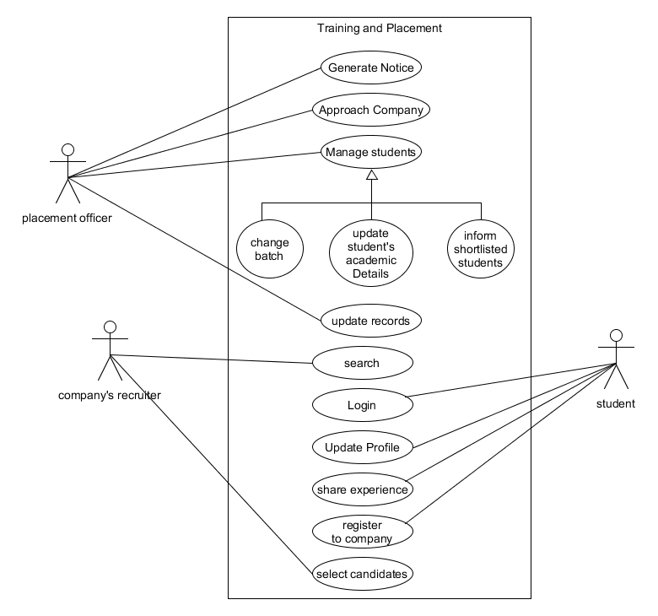

4.2 CLASS DIAGRAM

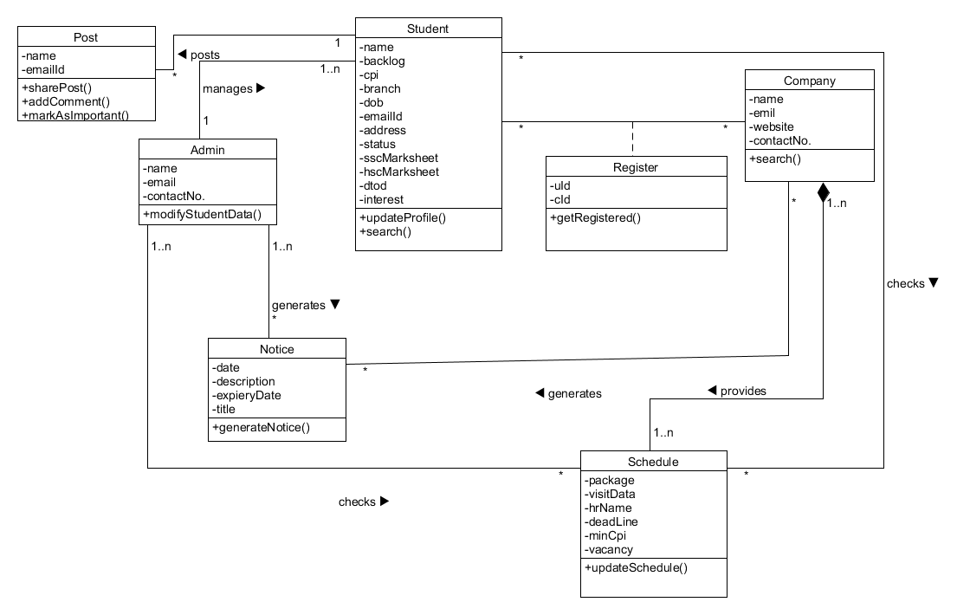

4.3 SEQUENCE DIAGRAM

4.3.1 SEQUENCE DIAGRAM FOR NOTICE
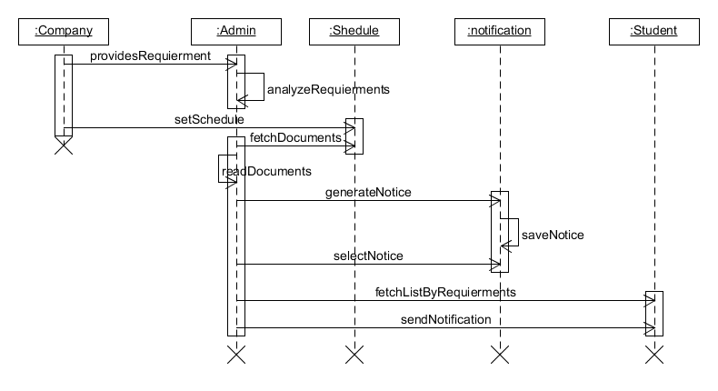

4.3.2 SEQUENCE DIAGRAM FOR
NOTIFICATION

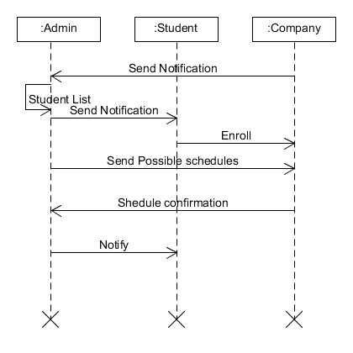

4.4 ACTIVITY DIAGRAMS
4.4.1 ACTIVITY DIAGRAM FOR NOTICE
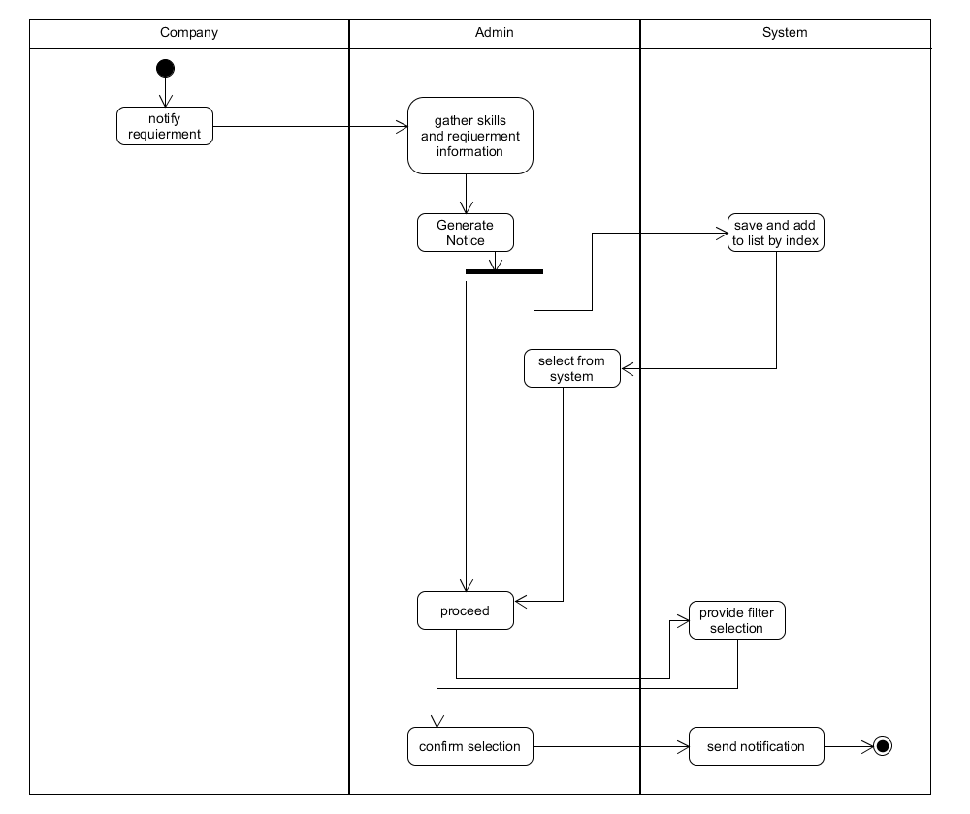

4.4.2 ACTIVITY DIAGRAM FOR PROFILE
UPDATE

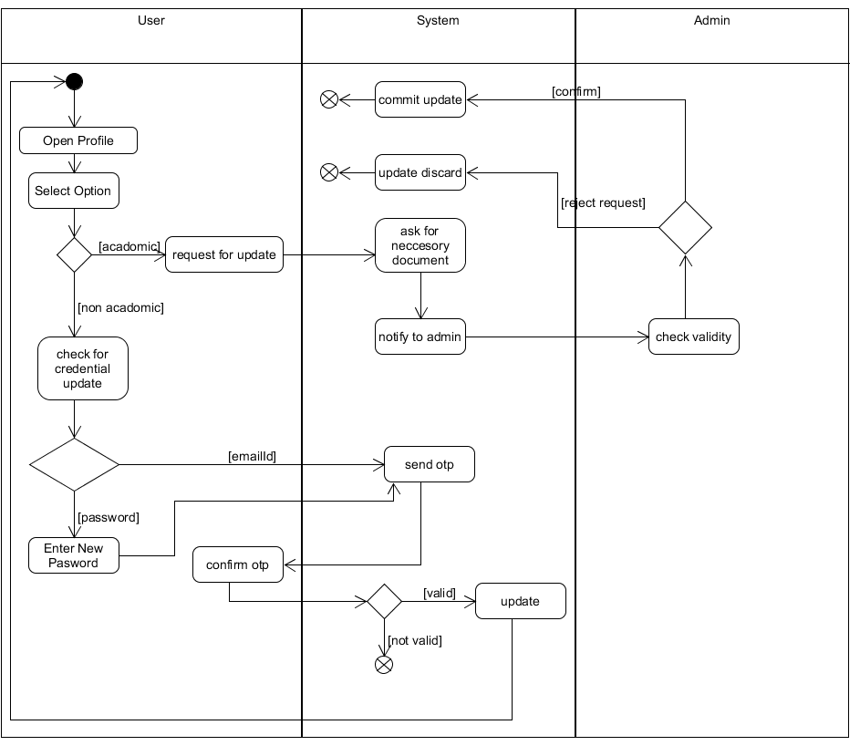

4.5 STATE DIAGRAM FOR NOTICE

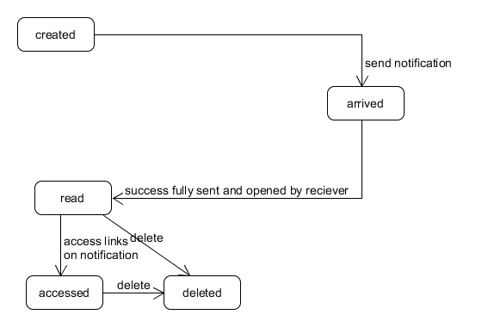

4.6 ER DIAGRAM
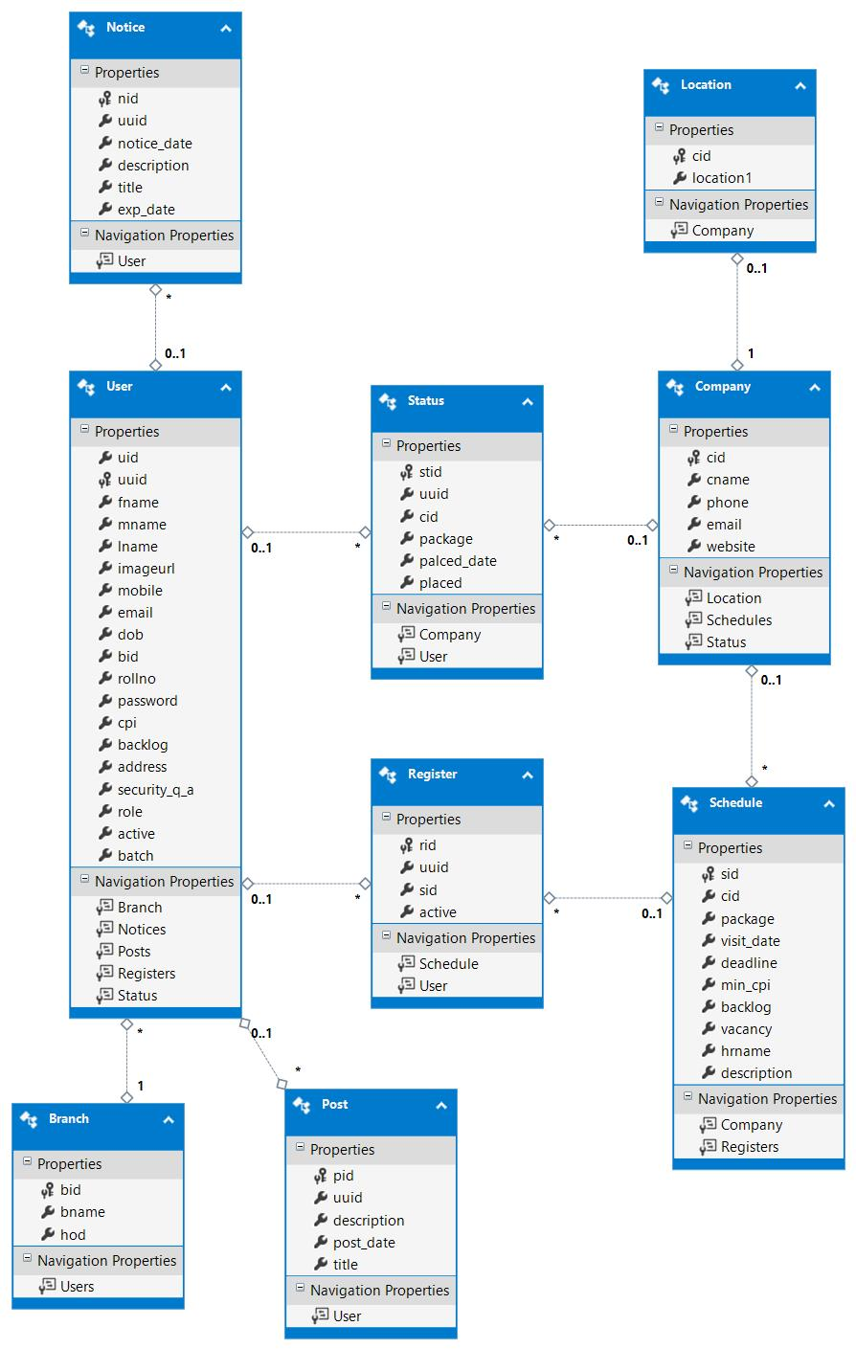

USER
Sr.No | Field Name | Data Type | Size | Constraint
1. | Uid | int |  | IDENTITY (1, 1) NOT NULL
2. | Uuid | varchar | 50 | NOT NULL,CONSTRAINT [PK_Users] PRIMARY KEY CLUSTERED ([uuid] ASC)
3. | Fname | varchar | 50
4.  . | Mname | varchar | 50
5. | Lname | varchar | 50
6. | Imageurl | varchar | MAX
7. | Mob_name | varchar | 50
8. | Email | varchar | 50
9. | Dob | datetime
10. | Bid | int |  | NOT NUL,  CONSTRAINT [FK_User_Branch] FOREIGN KEY ([bid]) REFERENCES [dbo].[Branch] ([bid])
11. | Rollno | varchar | 50
12. | Password | Varchar | 50
13. | Cpi | Float
14. | Backlog | Varchar | 50
15. | Brach | Varchar | MAX
16. | Notices | Varchar | 20
17. | Posts | Varchar | 50
18. | Registers | Varchar | 50
19. | Status | Varchar | 50
4.7 DATA DICTIONARY

GO
CREATE NONCLUSTERED INDEX [IX_FK_User_Branch]
ON [dbo].[User]([bid] ASC);

STATUS
Sr.No | Field Name | Data Type | Size | Constraint
1. | uuid | Varchar | 50
2. | cid | int |  | CONSTRAINT [FK_Status_Company] FOREIGN KEY ([cid]) REFERENCES [dbo].[Company] ([cid])
3. | package | float | 53
4. | palced_date | datetime
5. | placed | varchar | 50
6. | stid | int |  | IDENTITY (1, 1) NOT NULL,  CONSTRAINT [PK_Status] PRIMARY KEY CLUSTERED ([stid] ASC)

GO
CREATE NONCLUSTERED INDEX [IX_FK_Status_Company]

SHEDULE
Sr.No | Field Name | Data Type | Size | Constraint
1. | sid | int |  | IDENTITY (1, 1) NOT NULL,  CONSTRAINT [PK_Schedules] PRIMARY KEY CLUSTERED ([sid] ASC)
2. | cid | int |  | CONSTRAINT [FK_Schedule_Comapany] FOREIGN KEY ([cid]) REFERENCES [dbo].[Company] ([cid])
3. | package | float
4. | visit_date | datetime
5. | deadline | datetime
6. | min_cpi | float
7. | backlog | varchar | 50
8. | vacancy | int
9. | hrname | varchar | 50
10. | description | varchar | MAX

GO
CREATE NONCLUSTERED INDEX [IX_FK_Schedule_Comapany]
ON [dbo].[Schedule]([cid] ASC);

REGISTER
Sr.No | Field Name | Data Type | Size | Constraint
 | rid | int |  | IDENTITY (1, 1) NOT NULL,  CONSTRAINT [PK_Registers] PRIMARY KEY CLUSTERED ([rid] ASC)
 | uuid | varchar(50) | 50 | CONSTRAINT [FK_Registers_User] FOREIGN KEY ([uuid]) REFERENCES [dbo].[User] ([uuid])
 | sid | int |  | CONSTRAINT [FK_Registers_Schedule] FOREIGN KEY ([sid]) REFERENCES [dbo].[Schedule] ([sid])
 | active | varchar(50) | 50

GO
CREATE NONCLUSTERED INDEX [IX_FK_Registers_Schedule]
ON [dbo].[Register]([sid] ASC);

GO
CREATE NONCLUSTERED INDEX [IX_FK_Registers_User]
ON [dbo].[Register]([uuid] ASC);

POST VIEWS
Sr.No | Field Name | Data Type | Size | Constraint
 | fname | varchar(50) | 50 | NOT NULL  ,CONSTRAINT [PK_PostViews] PRIMARY KEY CLUSTERED ([pid] ASC)
 | lname | varchar(50) | 50
 | pid | int
 | uuid | varchar(50) | 50
 | description | varchar(MAX) | MAX
 | post_date | datetime
 | title | varchar(50) | 50

POST
Sr.No | Field Name | Data Type | Size | Constraint
 | pid | int |  | IDENTITY (1, 1) NOT NULL,  CONSTRAINT [PK_Posts] PRIMARY KEY CLUSTERED ([pid] ASC)
 | uuid | Varchar | 50 | CONSTRAINT [FK_Post_User] FOREIGN KEY ([uuid]) REFERENCES [dbo].[User] ([uuid])
 | description | Varchar | MAX
 | post_date | datetime
 | title | varchar | 50

GO
CREATE NONCLUSTERED INDEX [IX_FK_Post_User]
ON [dbo].[Post]([uuid] ASC);

NOTICE
Sr.No | Field Name | Data Type | Size | Constraint
 | nid | int |  | IDENTITY (1, 1) NOT NULL,  CONSTRAINT [PK_Notices] PRIMARY KEY CLUSTERED ([nid] ASC)
 | uuid | varchar(50) |  | CONSTRAINT [FK_Notice_User] FOREIGN KEY ([uuid]) REFERENCES [dbo].[User] ([uuid])
 | notice_date | datetime
 | description | varchar(MAX) | MAX
 | title | Varchar | 50
 | exp_date | datetime

GO
CREATE NONCLUSTERED INDEX [IX_FK_Notice_User]
ON [dbo].[Notice]([uuid] ASC);

MY VIEWS
Sr.No | Field Name | Data Type | Size | Constraint
 | uuid | Varchar | 50 | NOT NULL, CONSTRAINT [PK_MyViews] PRIMARY KEY CLUSTERED ([uuid] ASC)
 | fname | Varchar | 50
 | mname | Varchar | 50
 | lname | Varchar | 50
 | rollno | Varchar | 50
 | imageurl | Varchar | MAX
 | active | varchar | 50
 | sid | int

LOCATION
Sr.No | Field Name | Data Type | Size | Constraint
 | lid | int | 50 | IDENTITY (1, 1) NOT NULL,  CONSTRAINT [PK_Locations] PRIMARY KEY CLUSTERED ([lid] ASC)
 | location1 | varchar | MAX
 | cid | int | 50 | CONSTRAINT [FK_Location_Company] FOREIGN KEY ([cid]) REFERENCES [dbo].[Company] ([cid])

COMPANY
Sr.No | Field Name | Data Type | Size | Constraint
 | cid | int |  | NOT NULL, CONSTRAINT [PK_MyViews] PRIMARY KEY CLUSTERED ([uuid] ASC)
 | cname | varchar | 50
 | phone | varchar | 50
 | email | varchar | 50
 | website | varchar | 50

BRANCH WISE BY YEAR VIEWS
Sr.No | Field Name | Data Type | Size | Constraint
 | bname | varchar(50) | 50
 | bid | int |  | NOT NULL,  CONSTRAINT [PK_BranchwiseByYearViews] PRIMARY KEY CLUSTERED ([bid] ASC)
 | batch | int
 | total | int

BRANCH
Sr.No | Field Name | Data Type | Size | Constraint
 | bid | int | False | IDENTITY (1, 1) NOT NULL,  CONSTRAINT [PK_Branches] PRIMARY KEY CLUSTERED ([bid] ASC)
 | bname | Varchar | 50
 | hod | varchar | 20

5. IMPLEMENTATION

5.1 MODULES:
(Pages and its module)

Using .NET Entity Framework all the modules and functionalities are implemented.

5.1.1 home
- In home.aspx page admin generates notices, edit or remove existing notices.
And students view that notices.

5.1.2 Posts
- In post.aspx page students who are already placed they can share their experience with other students.

5.1.3 Upcoming Companies and Schedule
- In add_schedule.aspx admin add schedule of company with require credentials, based on that eligible students can register him/her self via upcoming_companies.aspx page.

5.1.4 Add Students
- In add_user.aspx page admin upload Excel file (.xls format) which contains appropriate students and their credentials list. Admin just upload a file and data uploaded into the database automatically.

5.1.5 Export Student List
- In update_status.aspx page admin downloads Excel file (.xls format) which contains list of students registered in appropriate company.

5.1.6 Profile Management
- In profile.aspx page student can edit his/her details and also change profile picture.

5.2 FUNCTION PROTOTYPES:

5.2.1 Student upload via Excel file
- In, this module admin can upload valid Excel file(.xls) which can contain list of student details and credential.
- Admin browse file and easily upload data into a database.

5.2.2 Student list export via Excel file
- In, this module admin can export data of grid view (list of students with appropriate details).
- For ex, if 150 students register for Amazon company that all student required details we can export this details in Excel file (.xls format)

5.2.3 Email Notification
- In, this module whenever student placed into the company or whenever admin wish to notify students for important notice, direct mail will be send to students which already registered.

5.2.4 Change password
- In, this module student can change his/her password.

6. TESTING

TESTING METHOD: Black Box Testing First Implementation done and deployment.
TEST CASES:
Entity | Test case | Expected  output | Actual  output | Result
Home.aspx | Notice generation | Success fully created and visible | Success fully  Creation | PASS
Post.aspx | Message generation | Successfully  Creation and visible to recipients | Successfully  Creation and visible to recipients | PASS
Add_user.aspx | Upload student via excel file(.xls) | Uploaded in database | Uploaded in database | PASS
Add_company.aspx | Company name and details register | Company added | Company added | PASS
Add_schedule.aspx | To schedule upcoming company | Upcoming company added | Added upcoming company | PASS
Update_status.aspx | List of registered students | Accessible list available | Accessible list  Available to update | PASS
Update_status.aspx | Export details | Export list file of registered students | List completely exported | PASS
Profile.aspx | Profile can be edited and changes can be commited | Profile modified successfully | Successfully modified profile | PASS
Global.asax | Session management | Any page can be accessible only after authentication from login wizard | Login first error message if try to access any page before login | PASS
Past.aspx | Past reports | Past year data analysis graphically and statically | Past analysis can be seen after login | PASS
7. SCREENSHOTS

7.1 Login Page
In login page student or admin login via their proper credentials.
If credential not valid then error message shown, otherwise successfully login
login into appropriate page.

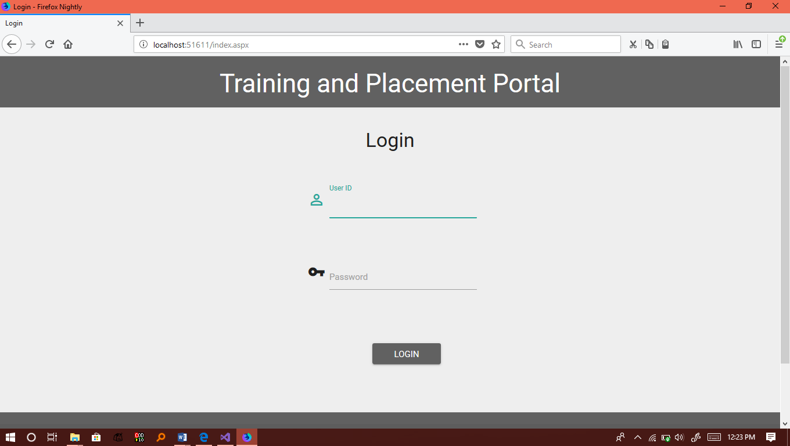

7.2 Login Page
In home page students can view notices uploaded by admin

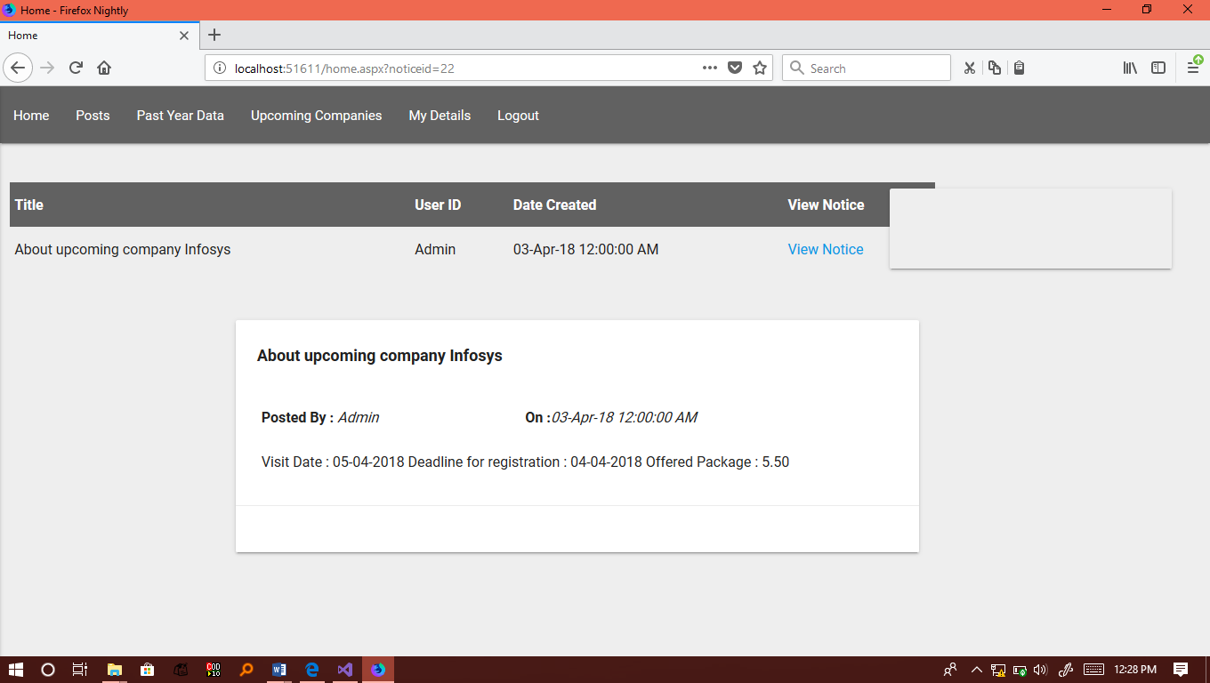
7.3 Post page
In Post page, students can see posts written by placed students.

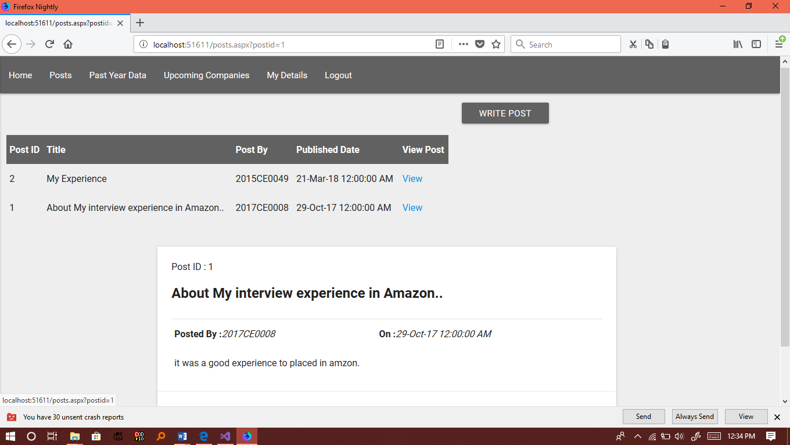

7.4 Past page
In Past page, students can see previous placement details

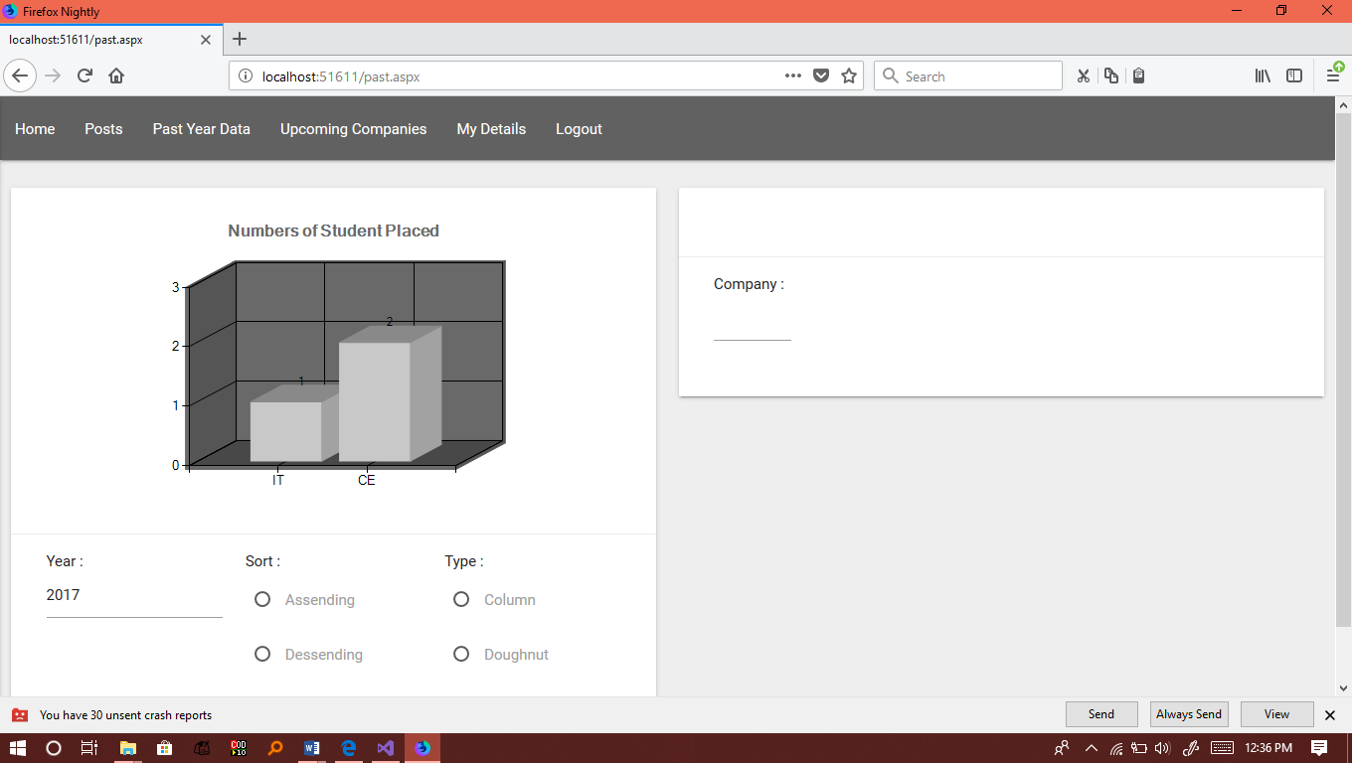

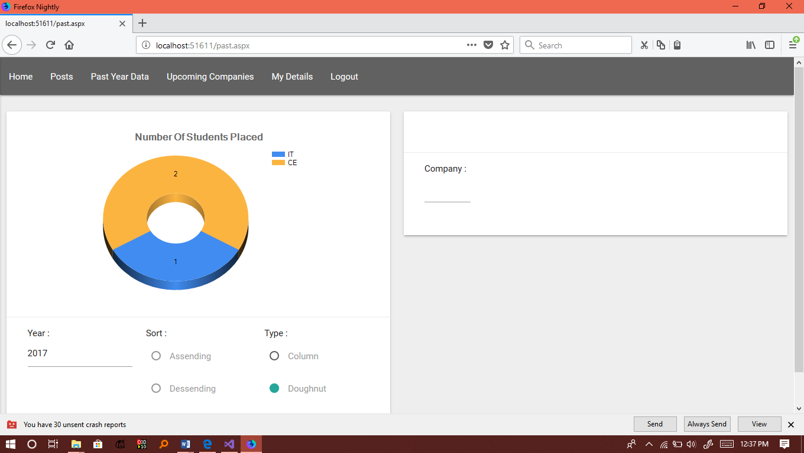

7.6 Page for register in company
Student register in company in which he/she is eligible.

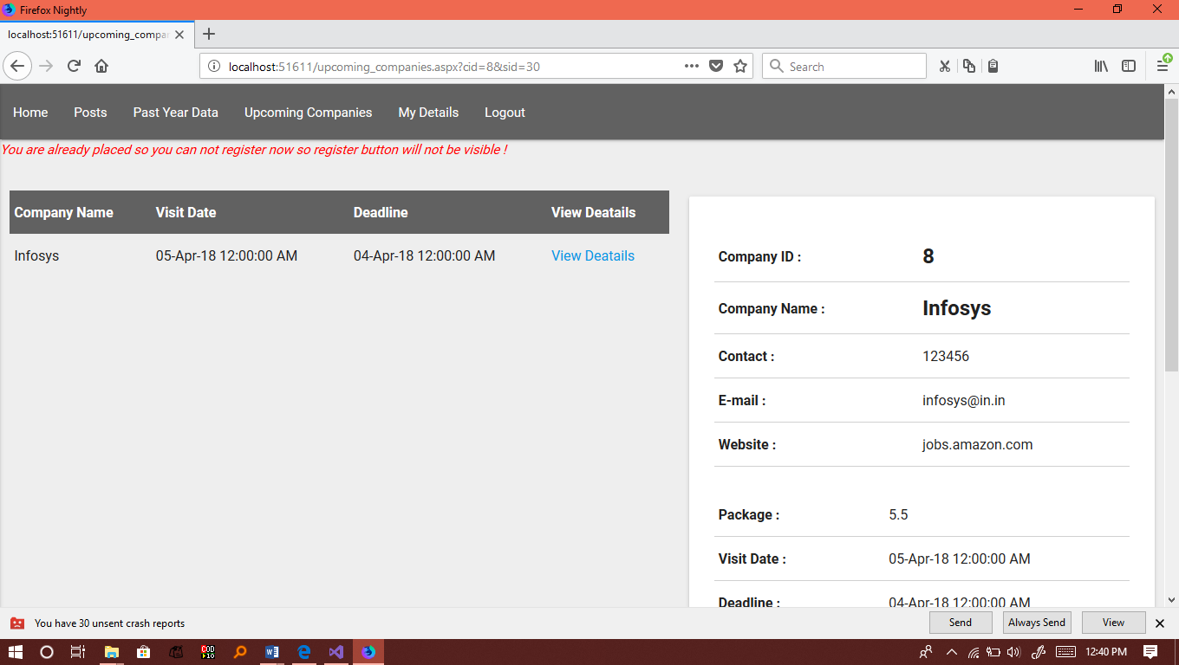

7.7 Profile page
Students can view and edit own profile.

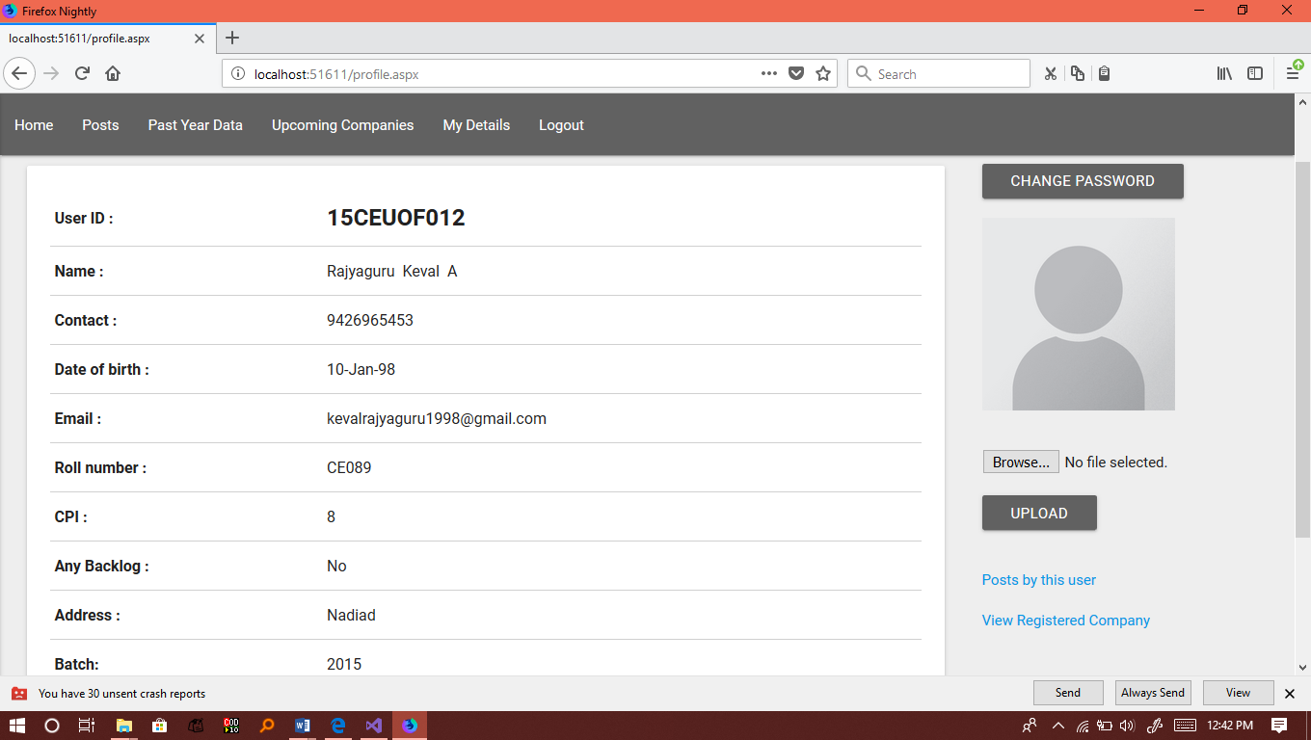

7.8 Add user page
Admin can upload details of users to database from Excel file.

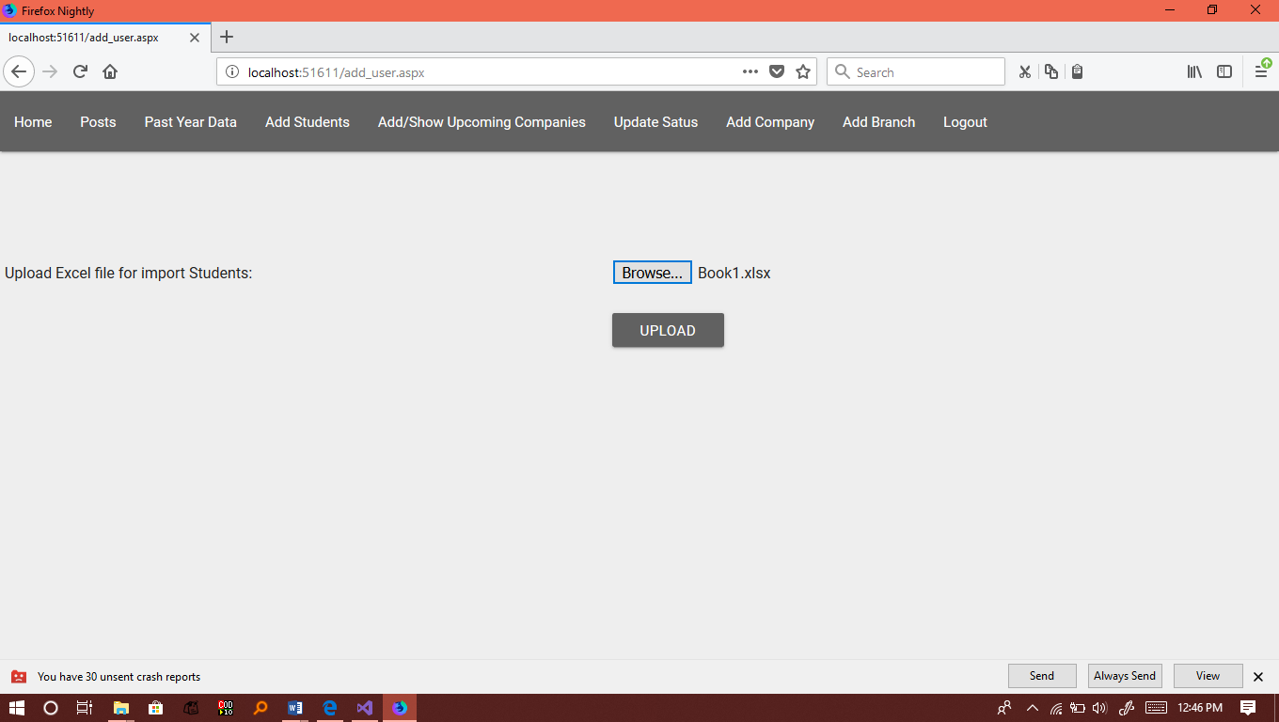

7.9 add schedule page
Admin add schedule for upcoming company that will visible to all the students.

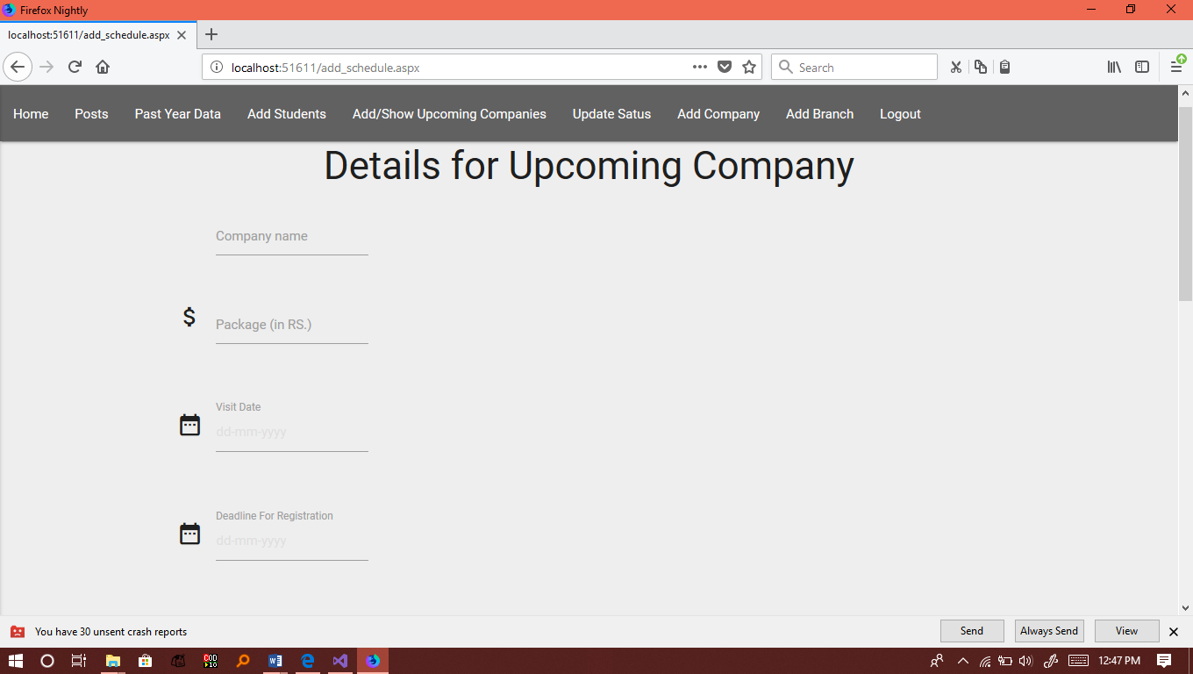

7.10 Add branch page
Admin add Branch for university.

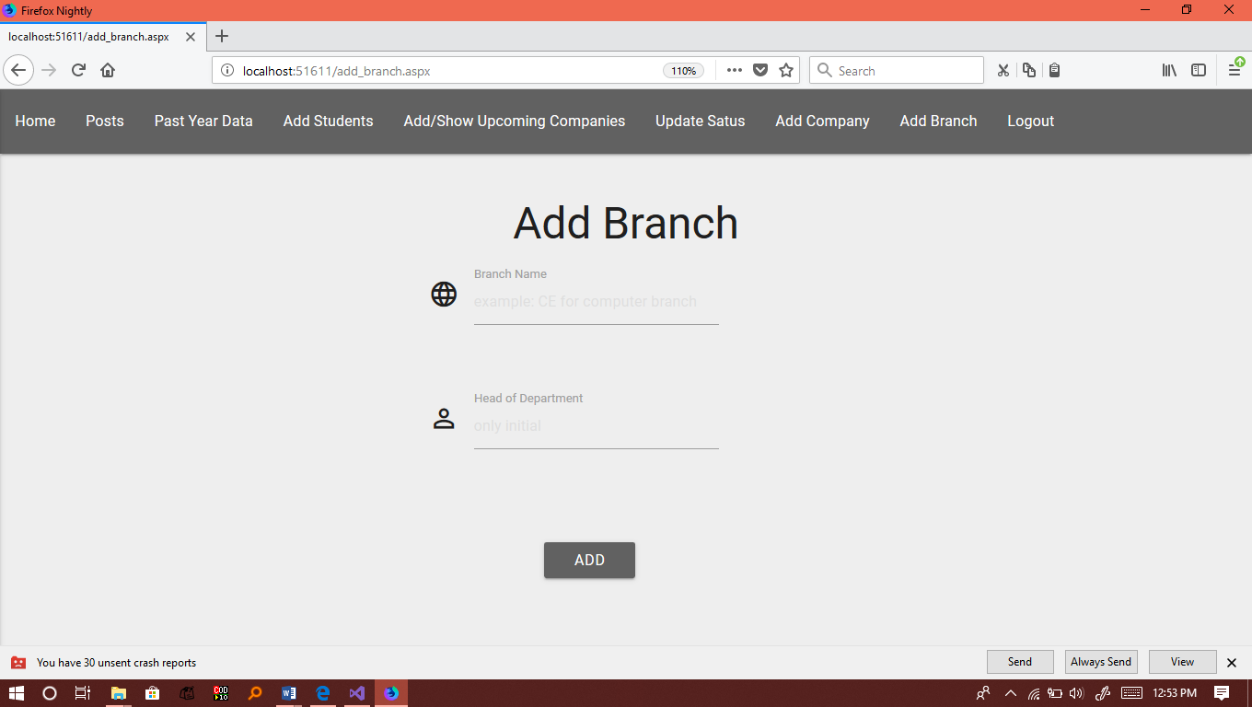

8. CONCLUSION

- This project Training and placement System is for making communication and some analysis little bit easy and feasible to placement and training management. System can send notice of upcoming companies for recruitment and awareness seminars and courses of trainings; and all these notices are controlled by admin of system who has special role. That includes notice generation, uploading company details, register students and companies and send mail to appropriate recipient. List of all registered students can be available for admin.

9. LIMITATIONS & FUTURE EXTENSION

Limitations

Admin cannot search students who are already placed.

Future Extension

Admin can search based on all criteria.

Companies are also allowed to register and provide notification and events to appropriate role.

10. BIBLIOGRAPHY

REFERENCES

Microsoft .Net Development site
Microsoft visual studio 2015/2017 Documentation
NuGet Package Manager for some dll files
-ExelfileReader.dll
-AjaxControlToolkit.dl
Online Standard Resources / Websites

11. MISCELLAEOUS

SOFTWARE(s)
Microsoft Visual Studio
[ Community Version,
2017
With required resources]

TECHNOLOGIES

ASP.NET Support
.NET framework
C# Language Support
Entity Framework 6.0

